**Format of submission**

Submission contains MATLAB files with necessary code and .docx file with results and explanations which has to be archived in **ZIP FILE** with the following name:

lab<#>_<IDnumber1>_<IDnumber2>, where # is a lab number.

**Lab 3: Image Resizing**

**Tasks to do:**

1. Read the files Lecture_resizing and Lab3_resizing
2. Open the files EX3_1.m and read the code.
3. Take the RGB image bird.jpg and save it as a matrix using function imread(). The image size is 165*305*3 (rows*cols*colors)

**Independent work 1:**

1. Write 2 functions for Down Sampling the original image to size ((rows/2)*(cols/2)*3):

-without filtering and

-with filtering.

1. Write 3 functions for Up Sampling the original image to size ((rows*2)*(cols*2)*3) with the methods:

-nearest up-sampling,

-bilinear up-sampling,

-bicubic up-sampling.

1. Show the results or Down sampling without filtering and with filtering as a subplot in according to Figure 1.
2. Show the results or Up sampling for the 3 methods: nearest, bilinear and bicubic up-sampling in according to Figure 2, 3, 4.

Figure 1. Down sampling

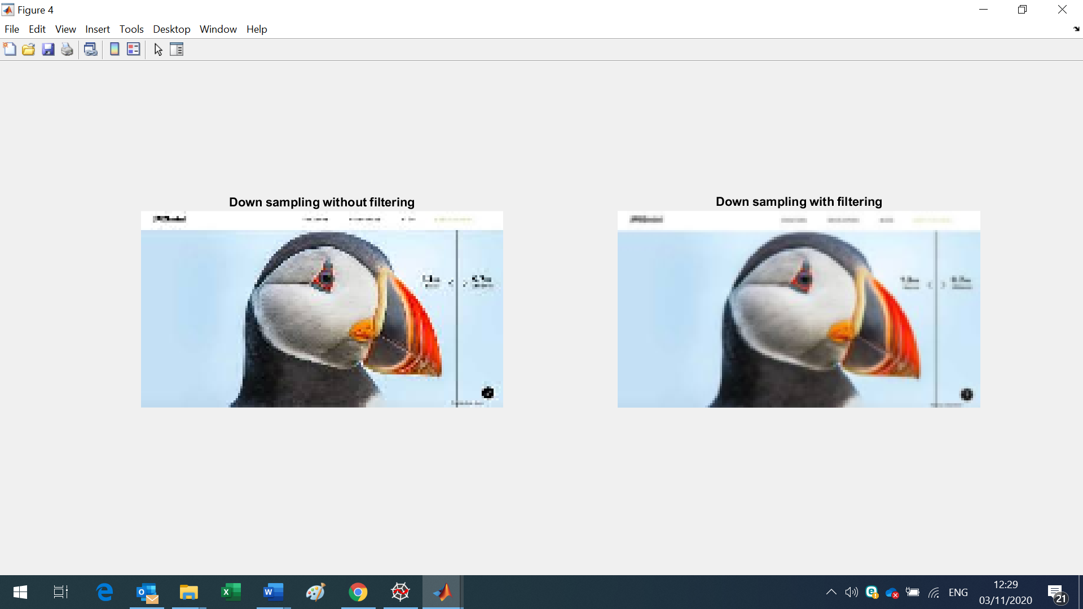

Figure 2. Nearest Up sampling

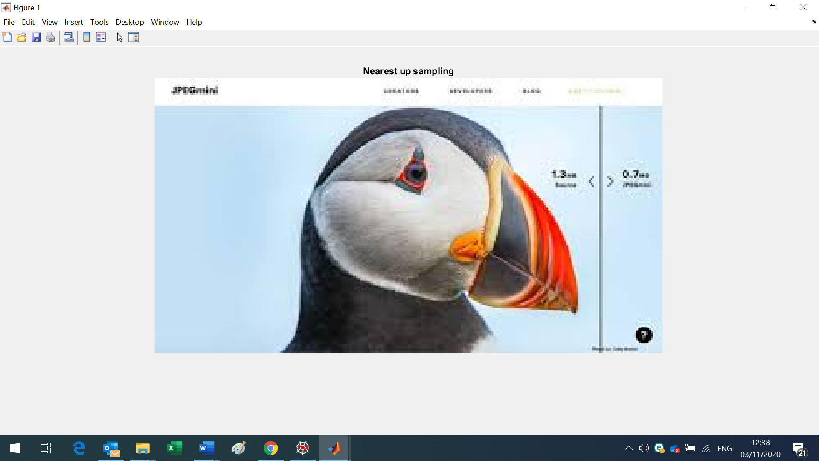

Figure 3. Bilinear Up sampling

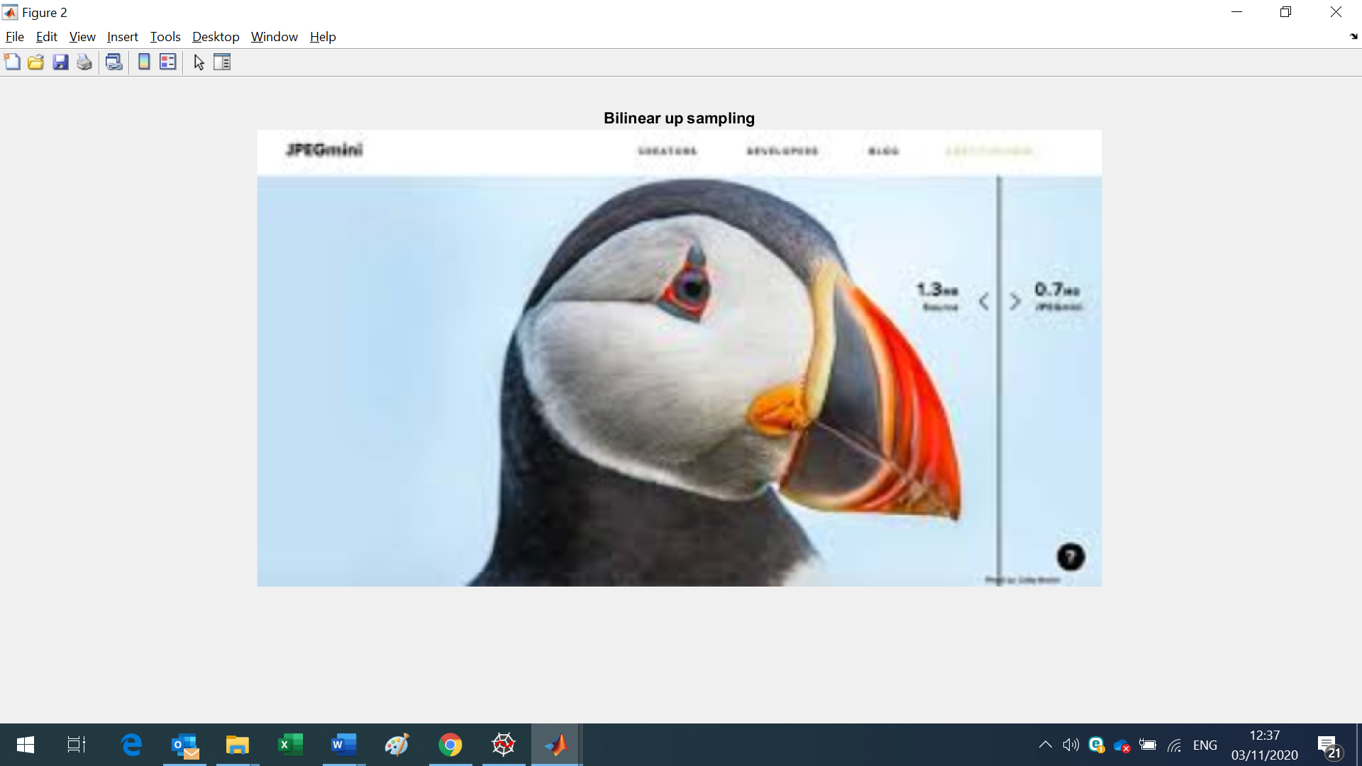

Figure 4. Bicubic Up sampling

